**Ornithopter Flapping Wing Mechanism**

**ABSTRACT**

Ornithopters, commonly referred to as flying objects with flapping wings, have garnered attention recently due to their potential usage in micro aerial vehicles (MAVs). A flying vehicle with wings that flap for propulsion is called an ornithopter.

Lift and push are both produced by flapping. It is, by far, the most propeller-efficient flight that is currently feasible. Ornithopters have been produced for covert surveillance as well as to research the aerodynamics of flapping wings due to their close physical and flying similarities to insects and birds.

The design of the wing mechanism results in minimal drag and optimum propelling efficiency. Additionally, the ornithopter should be able to transport a sizable payload without negatively impacting its flight characteristics. A great degree of manoeuvrability in the tail design is also attempted. The system contains electronics. The project is essentially a bio mimicry.

**1.INTRODUCTION**

Ornithopters are a type of flying drone that takes flight by flapping its wings in a manner like to a bird. Typical ornithopters utilise a whole membrane. wing that only has one degree of flexibility during flapping.

Aerofoil wings provide lift, and engines provide propulsion, for the aircraft. The design of the bird wing, which flaps its wing several times during upward stroke to reduce the effort in the upward stroke that does not provide lift, combines aerofoils and membrane. An array of gear reductions are used by the flapping mechanism to get the desired frequency of flapping out of a high speed motor. The wings are fully stretched during the downward stroke, which generates both lift and thrust, in order to displace the most air possible beneath the wing in order to generate thrust. The bird took off. Compared to any other type of flight (fixed wing flight, rotor flight), (flapping flight) has the highest propulsive efficiency.

**2.DESIGN OF COMPONENTS**

Design of the ornithopter consists of four sections.

i. Wing and tail design

ii. Flapping mechanism

iii. Gear box.

**3.Wing and Tail design**

The wing is the member that generates lift. The wing is designed by bio mimicry of falcon wing. A bird wing is divided into three sections.

1. **Primary section**

This is the section of wing which has a pure membrane structure and with largest area. The maximum amount of lift and thrust are produced by this section with a vortex formation.

1. **Secondary section**

This section is a combination of aerofoil and membrane. The thick aerofoil gradually turns into membrane moving away from the bird body

1. **Tertiary section**

This is the section near the bird body. It is an aerofoil section with high camber and small area. This section helps the bird with a small amount of lift while gliding and up stroke

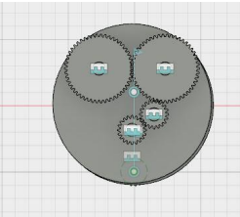 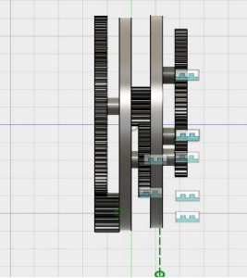

**4. FLAPPING WING MECHANISM**

The mechanism includes a slider crank mechanism and two bell crank mechanisms on each wings. Altogether the wing have a total of three degrees of freedom. To develop flapping flying, a machine that generated a flapping motion was built. Using a single engine and a flexible, light wing structure, the flapping flight was created. The thrust and lift force of the ornithopter were then measured using a force balance composed of a load cell. Three sets of wings with varied degrees of flexibility were created, and lift and thrust measurements were taken from each set of wings.

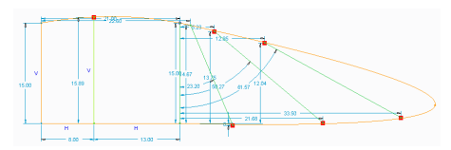

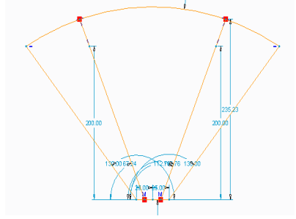



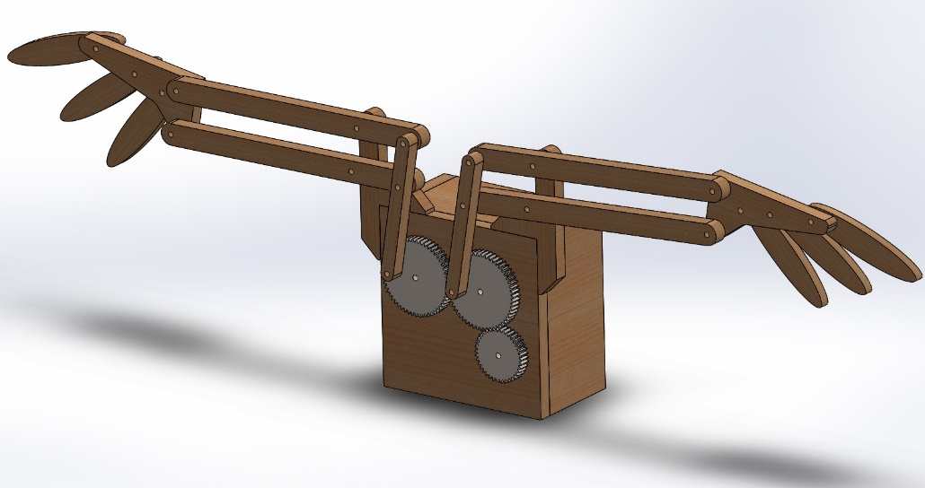

**ISOMETRIC VIEW**

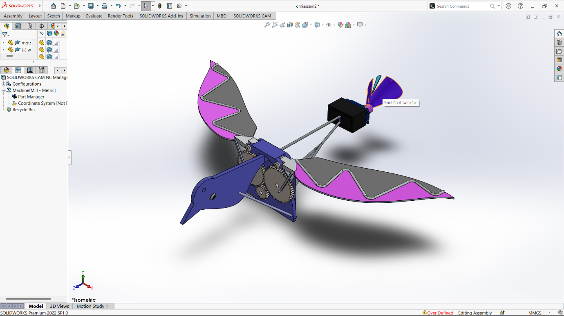

**TOP VIEW**

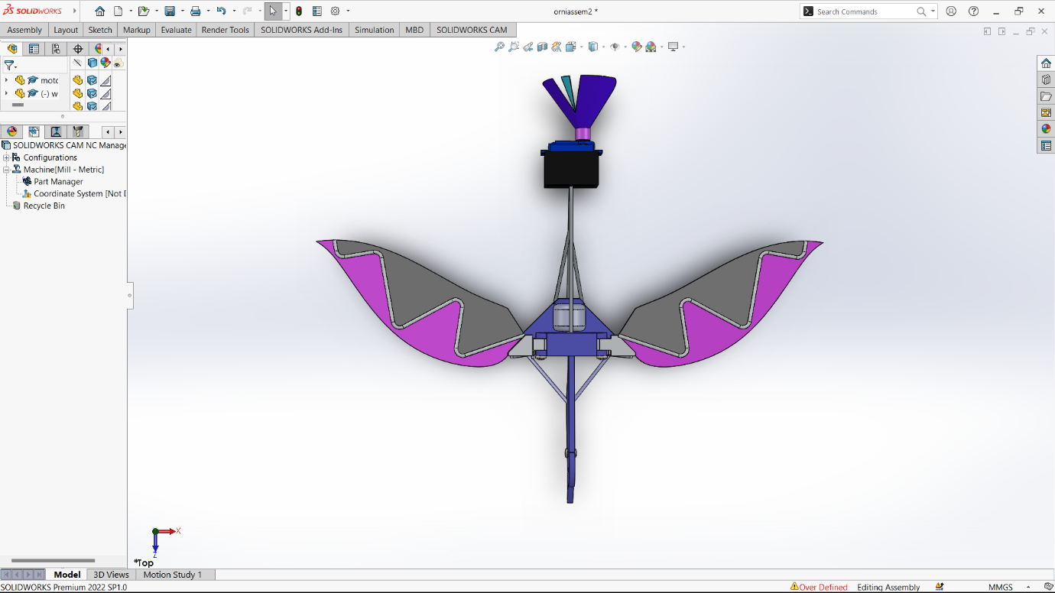

**BACK VIEW**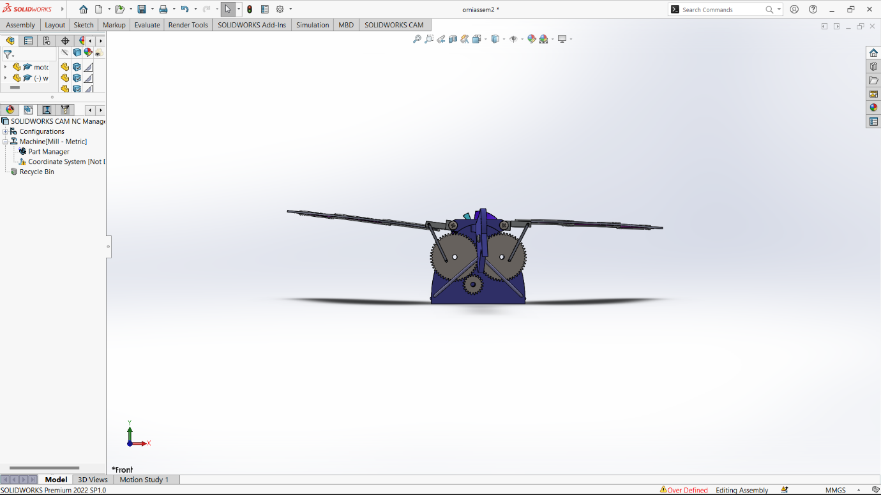

**SIDE VIEW**

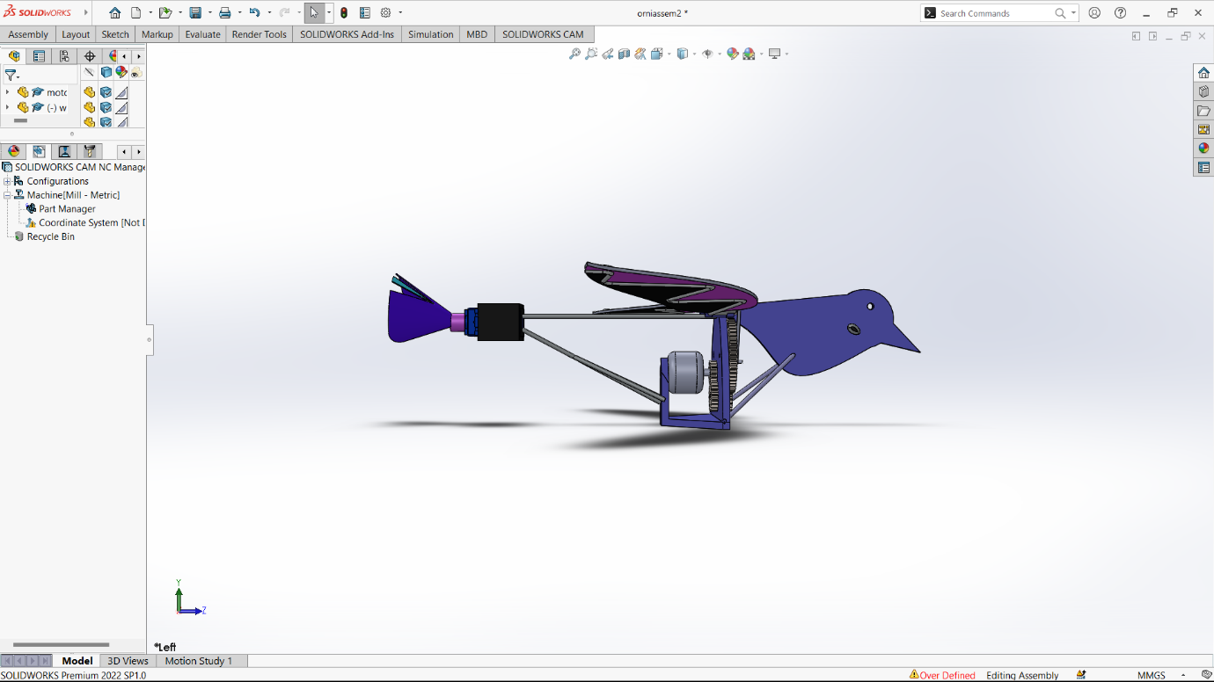

**How to perform certain motion-**

**1)** Go to the solidwork motion in Solidwork Add-In tab

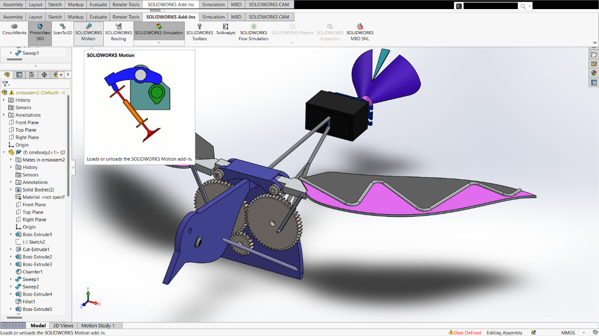

**2) First select the motor (Circular Motion) and select the shaft**

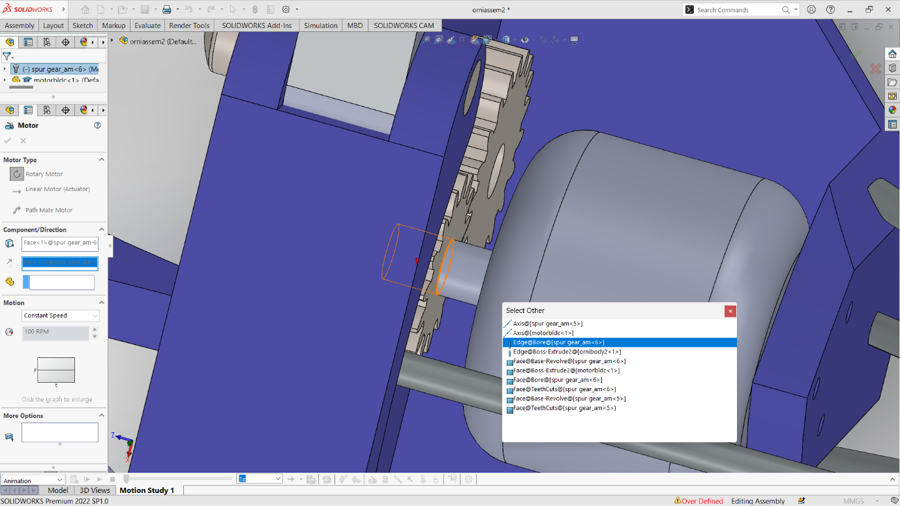

**3)**Select the interface which the motion is wrt and spped of motion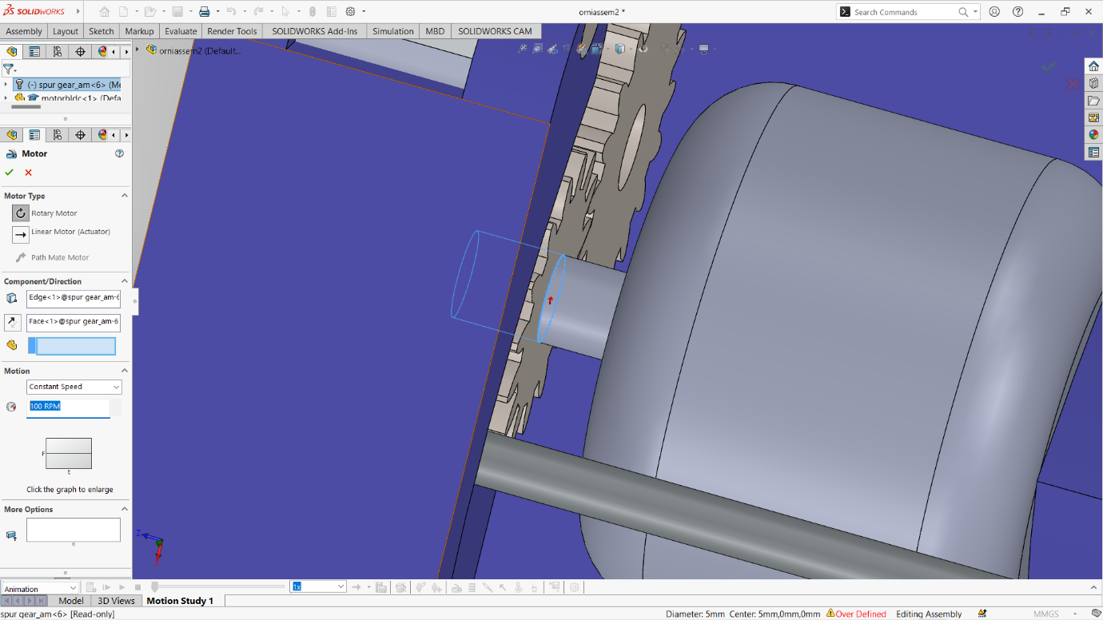

**4)**Play the Annimation-



**5.CONCLUSIONS**

Ornithopter is a large field that needs further investigation.

Even though research is continuing to the best of its ability, an effective design with the agility and mobility of a bird has not yet been achieved. A standing model was successfully made by our team. However, it is necessary to produce an ornithopter that is compatible with the systems and can fly according to the design. The lack of suitable materials and manufacturing techniques limits the capacity to create such an ornithopter. Additionally, the measurements must be extremely precise in order to perform a symmetrical flapping and prevent a rolling effect.

The ability to carry a larger payload is one of the most important qualities. Only by enhancing the aerodynamics and power can this be raised. The eight is increased by boosting power collectively, which is undesirable. We therefore need better batteries with higher power to weight ratios.

**Refrences-**

1) International Research Journal of Engineering and Technology (IRJET)

2) Ornithopter.org

**Submitted By-**

Ayush Gupta

(IInd Year Mechanical Engineering)

Zakir Hussain College of Engineering and Technology, AMU, Aligarh